**LinkedIn**

1. Liking Group post(1hr)

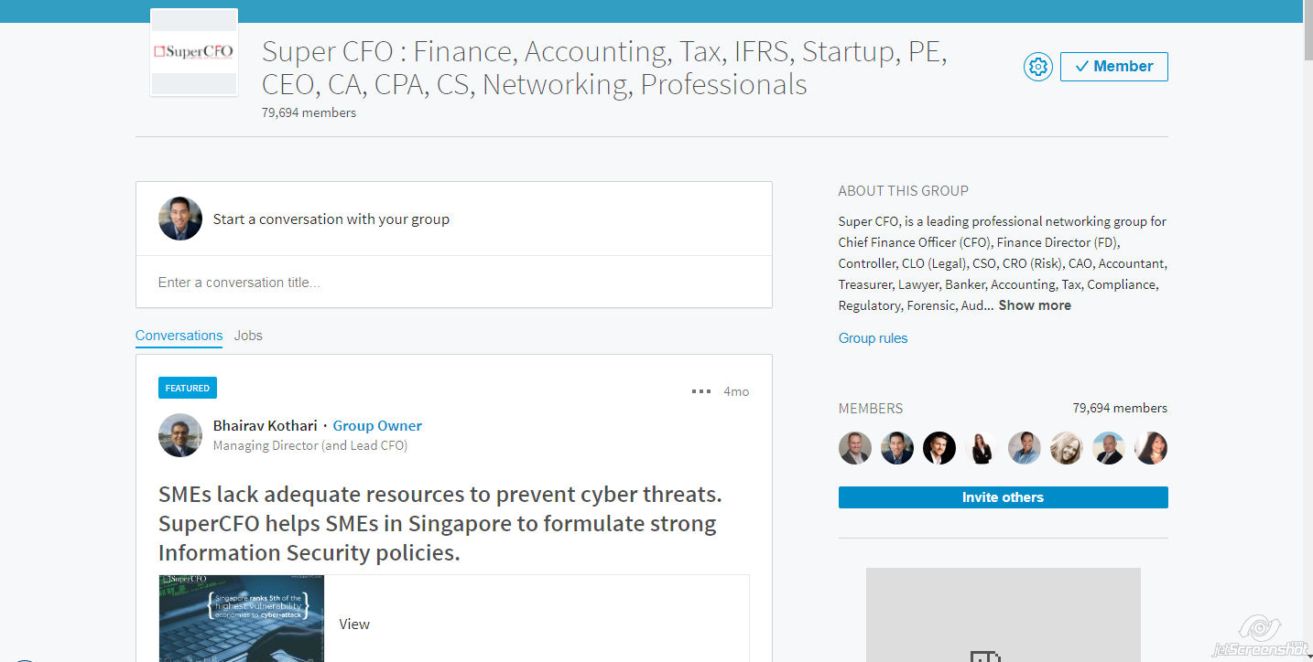

1. Liking home feed content (1hr)

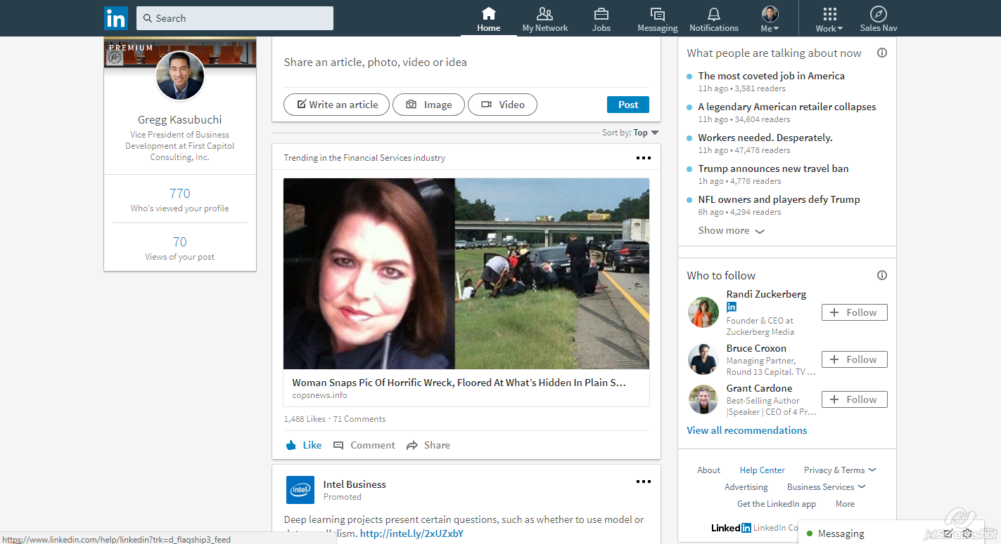

1. LinkedIn Messaging active members about recent post (30 min)

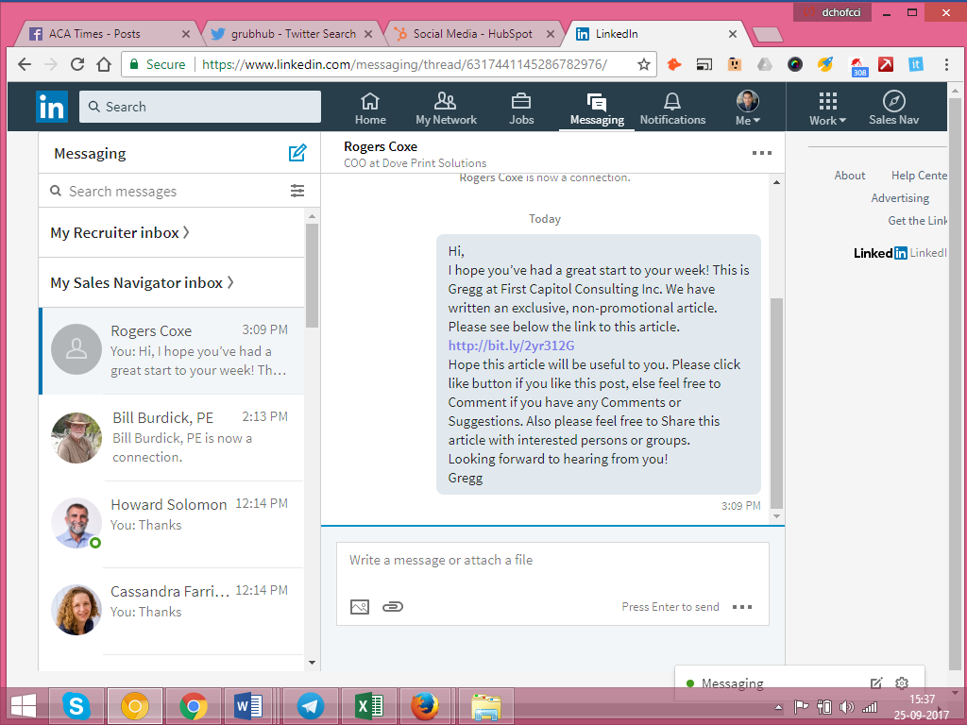

1. LinkedIn Messaging New connected members(20 min)

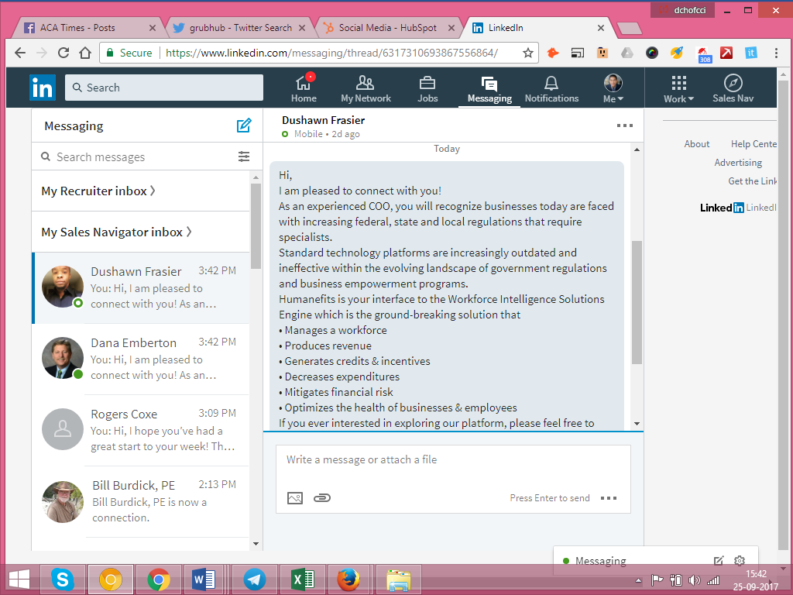

1. LinkedIn sending Connect Request COO, South Carolina (1hr)

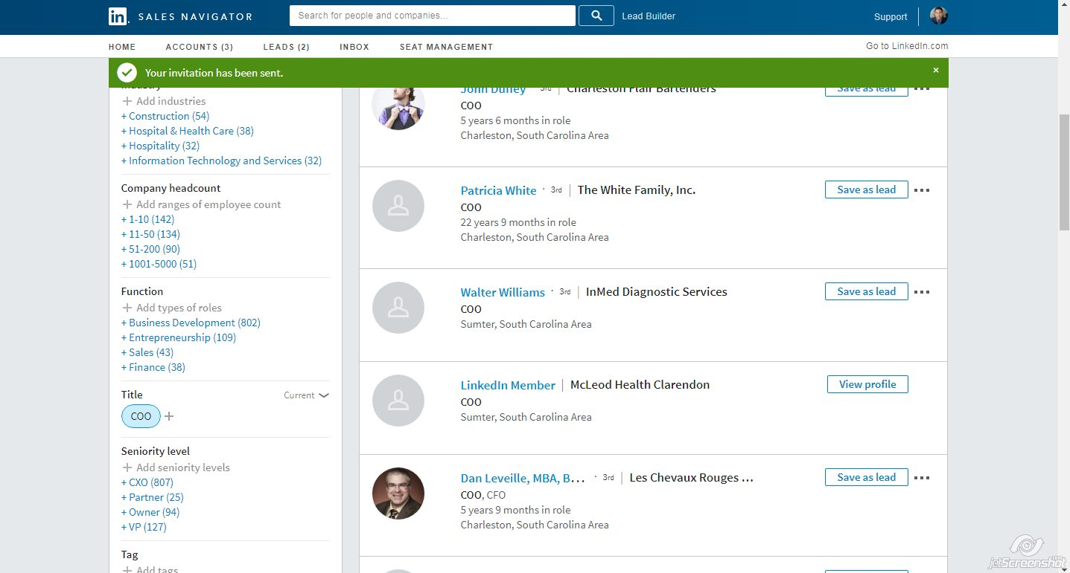

**Twitter**

1. Searching and Following CPAs and posting Tweets

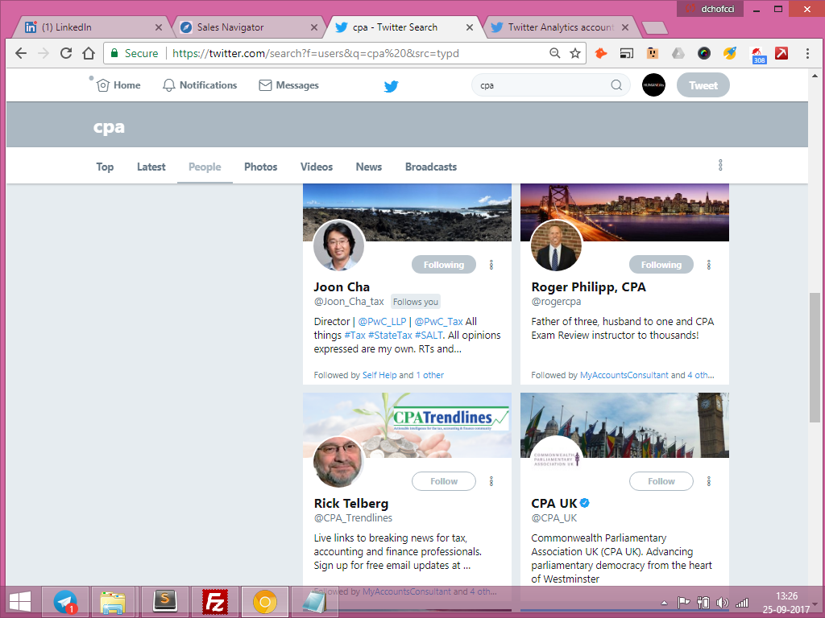

Searching and Following CEOs, Small business owners of Houston(1hr)

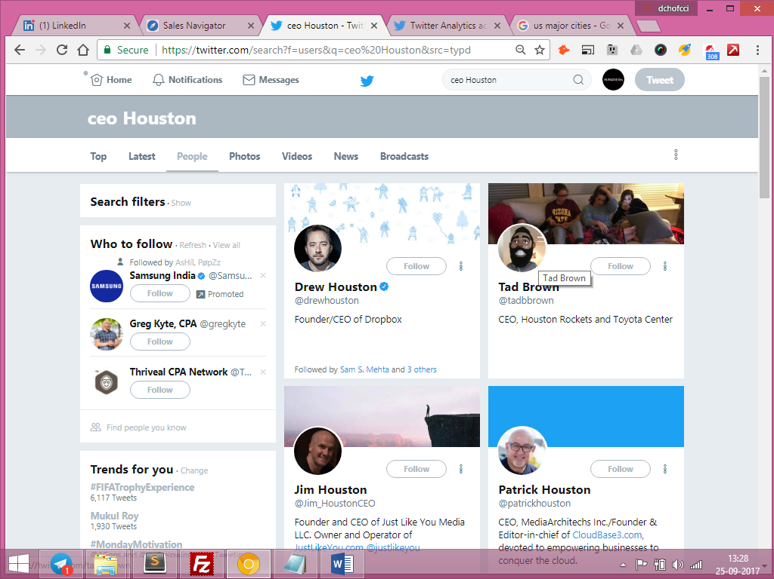

1. Liking Followers post (1hr)

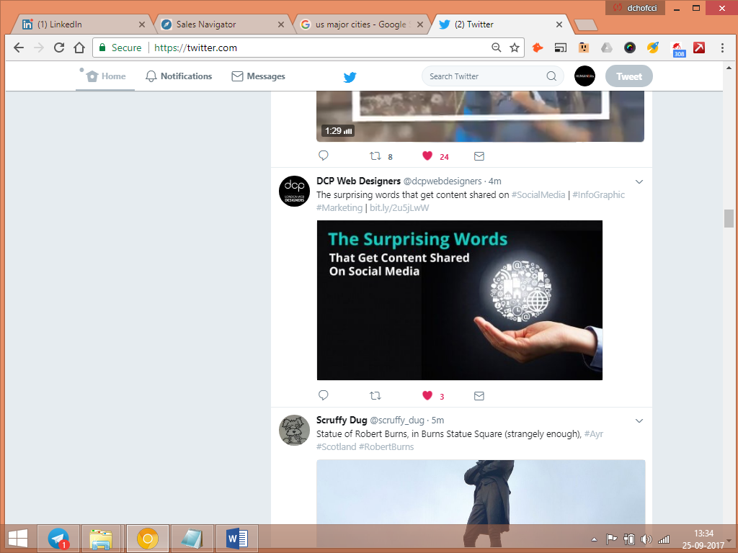

1. Editing and Sharing post to groups in Facebook (1hr)
2. Searching, sending Request and sending Individuals Messages about new FB post (3hrs)
3. Researching Keywords and its Related Keywords for today’s post (1hr)

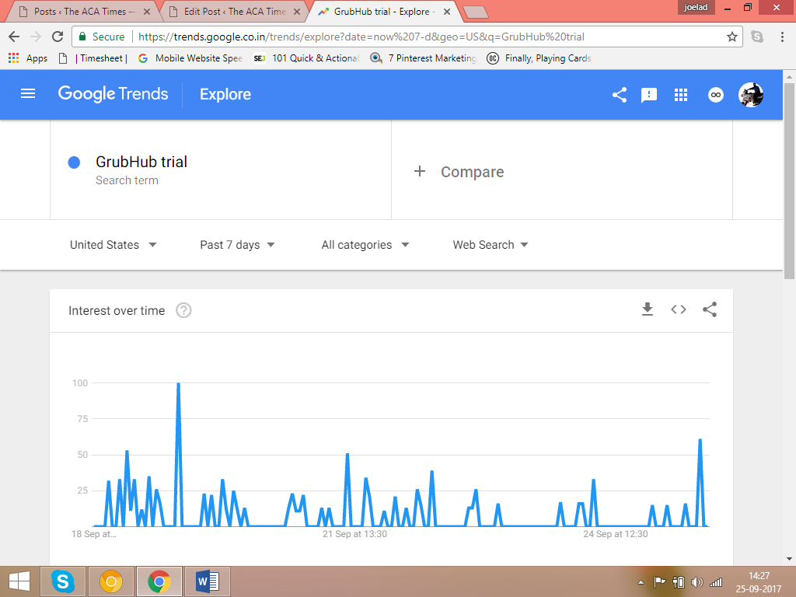

1. Adding Schema and AMP (1.30hrs)
2. Checking Webmaster, Bing Webmaster, Google Analytics and Hubspot(2hr)